Lutherans For Life
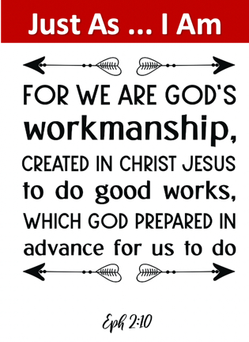
2023 Iowa
Essay Contest

Sponsored by the Council of Federation Presidents

For Students in Grades 6 through 12
Any student in a Lutheran school or Lutheran congregation, e.g., confirmation class or youth group, when validated by a pastor or teacher, is eligible. Students may also enter through a Lutheran home school, when validated by their Lutheran pastor.
Contest Guidelines
Students will write a life-affirming essay based on the theme: Just As ... I Am with the Bible verse: “For we are his workmanship, created in Christ Jesus for good works, which God prepared beforehand, that we should walk in them.” Ephesians 2:10

- Not incorporating the theme and verse in the essay will disqualify the entry.

- Examples of topics the essay could deal with are, but are not limited to abortion, the handicapped, adoption or foster care, infanticide, cloning, stem cell research, physician assisted suicide or euthanasia etc.

- Essays should include student’s name, grade (school or church), and email address. All entries submitted by a teacher or pastor, should include their name and email address. This information should be submitted on the rubric page used in grading the essay.

- All sources for references, statistics and quotes should be incorporated within the essay and then included in a bibliography at the end.
Grades 6 - 8 should submit essays up to 400 words
Grades 9 - 12 should submit essays up to 750 words

Entries should be submitted digitally using Microsoft Word or Google Docs to LFLofIowa@gmail.com by
April 1, 2023.

- There will be a $100 first place award and $50 second place award for each of the two categories. The two first place category winners will advance to the national contest. Email LFLofIowa@gmail.com with any questions.

- Grand prize for the national winning entries in each category if: $250 for first place plus free conference registration to the 2023 Lutherans For Life conference and one night stay at the conference hotel. $125 for the second-place winner.

- All entries become the property of Lutherans For Life.
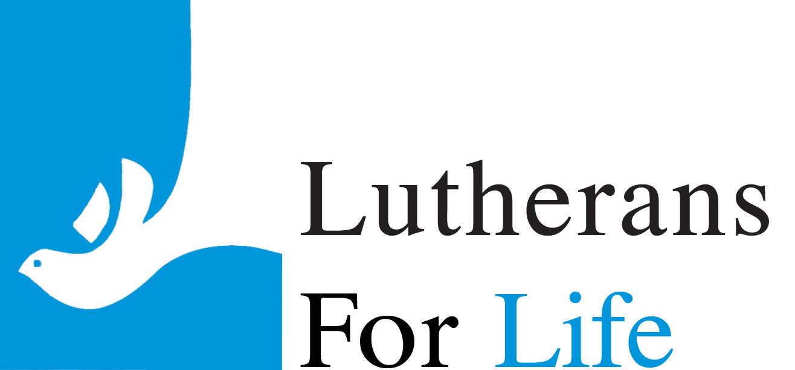
- For questions or resources on the sanctity of life, see lutheransforlife.org

